DOCKER - 1

1. Setup a Virtual Machine Using Ubuntu Image

Objective :
The objective is to create and configure a virtual machine (VM) using an Ubuntu Linux image.

Prerequisites
Before creating the VM, we need:
- Virtualization software
  - Oracle VirtualBox, VMware Workstation, or Hyper-V
  - we can use Oracle VirtualBox.
- Ubuntu ISO image
  - Ubuntu Server or Ubuntu Desktop ISO
  - For DevOps practice, Ubuntu Server is generally sufficient.
- Basic Linux knowledge
  - ls
  - cd
  - pwd
  - sudo
  - apt
  - systemctl

Step-by-Step Implementation

Step 1 — Install VirtualBox
Download and install Oracle VirtualBox on your host machine.
After installation, open:
Oracle VM VirtualBox
You should see the VirtualBox Manager window.

Step 2 — Download Ubuntu ISO
Download the Ubuntu ISO image.
For a server/DevOps lab, use:
Ubuntu Server 24.04 LTS
The downloaded file will look similar to:
ubuntu-24.04.x-live-server-amd64.iso
Keep this ISO file in an easily accessible location.

Step 3 — Create a New Virtual Machine
Open VirtualBox.
Click:
New
Enter:
Name: Ubuntu-DevOps-VM
Type: Linux
Version: Ubuntu (64-bit)
Select the downloaded Ubuntu ISO under the installation media option.
Then click:
Next

Step 4 — Configure Hardware
Allocate resources to the VM.

Recommended lab configuration
RAM: 4 GB
CPU: 2 CPUs
Disk: 30 GB
For a simple Linux practice VM, 2 GB RAM can work, but 4 GB RAM is more comfortable for DevOps tools.
Click:
Next

Step 5 — Create Virtual Hard Disk
Select:
Create a Virtual Hard Disk Now
Configure:
Disk Size: 30 GB
Select:
Dynamically Allocated
Then click:
Next
→ Finish
The VM will now be created.

Step 6 — Start the VM
Select:
Ubuntu-DevOps-VM
Click:
Start
The VM will boot from the Ubuntu ISO.
You should see the Ubuntu installation screen.

Step 7 — Start Ubuntu Installation
Select:
Try or Install Ubuntu Server
Press:
Enter
The Ubuntu installer will start.

Step 8 — Select Language
Choose:
English
Click:
Done

Step 9 — Configure Keyboard
Select your keyboard layout.
For a standard setup:
Layout: English (US)
Variant: English (US)
Click:
Done

Step 10 — Configure Network
Ubuntu normally detects the virtual network automatically.
You may see an interface such as:
enp0s3
with an IP address obtained through DHCP.
For example:
enp0s3
192.168.1.105
For the initial lab, keep the default DHCP configuration.
Click:
Done

Step 11 — Configure Proxy
If you don't use a proxy, leave it blank.
Proxy address:
Leave empty.
Click:
Done

Step 12 — Configure Ubuntu Archive Mirror
Ubuntu will provide a default mirror such as:
http://archive.ubuntu.com/ubuntu
Keep the default unless your organization provides a different mirror.
Click:
Done

Step 13 — Configure Storage
Select:
Use an entire disk
You should see the virtual disk, for example:
30 GB
The important point is that this is the virtual disk, not your physical Windows disk directly.
Select:
Set up this disk as an LVM group
if that option is available and appropriate for your lab.
Then continue.

Step 14 — Confirm Storage Configuration
Ubuntu will display the proposed partition configuration.
Review it.
For example:
Filesystem
/
and:
30 GB disk
Select:
Done
Ubuntu will ask for confirmation because the disk will be formatted.
Select:
Continue

Step 15 — Create User
Create the initial Ubuntu user.
Example:
Your name: Swaroop
Server name: ubuntu-devops
Username: swaroop
Password: ********
The hostname can be:
ubuntu-devops
The username will be used to log in to the server.

Step 16 — Install OpenSSH Server
This is very important for DevOps practice.
When you see:
Install OpenSSH server
select:
[x] Install OpenSSH server
Why?
Because later we can connect to the Ubuntu VM remotely using:
ssh username@IP_ADDRESS
This is useful for practicing:
- SSH
- Ansible
- Jenkins agents
- Linux administration
- Docker
- Kubernetes
- Remote deployments
Click:
Done

Step 17 — Additional Packages
Ubuntu may display optional packages.
For the basic VM lab, you can skip them.
Select:
Done
Installation will begin.

Step 18 — Wait for Installation
Ubuntu will install:
- Linux kernel
- System utilities
- Network configuration
- OpenSSH
- Bootloader
- Required packages
Wait until installation completes.
You should eventually see an option similar to:
Reboot Now
Select it.

Step 19 — Remove ISO
After reboot, VirtualBox may ask you to remove the installation media.
If required:
Devices
↓
Optical Drives
↓
Remove disk from virtual drive
Then press:
Enter
The VM should now boot from its virtual hard disk.

Step 20 — Login to Ubuntu
You should see:
Ubuntu
ubuntu-devops login:
Enter your username:
swaroop
Then enter the password.
After successful login:
swaroop@ubuntu-devops:~$
The Ubuntu VM is now ready.

Step 21 — Verify the Operating System
Run:
cat /etc/os-release
Example:
NAME="Ubuntu"
VERSION="24.04 LTS"
ID=ubuntu
You can also run:
uname -a
This displays the Linux kernel information.

Step 22 — Check IP Address
Run:
ip addr
or:
hostname -I
Example:
192.168.1.105
This IP can be used for SSH connectivity from another machine, depending on the VM's network mode.

Step 23 — Test Internet Connectivity
Run:
ping -c 4 google.com
Expected result:
64 bytes from ...
64 bytes from ...
64 bytes from ...
64 bytes from ...
This confirms that the VM has internet connectivity.

Step 24 — Update Ubuntu
Run:
sudo apt update
Then:
sudo apt upgrade -y
This updates the package information and installed packages.

Step 25 — Verify SSH
Check SSH service:
sudo systemctl status ssh
You should see:
Active: active (running)
If SSH is not running:
sudo systemctl enable --now ssh

Step 26 — Test SSH Connection
From another Linux machine or Windows PowerShell:
ssh swaroop@192.168.1.105
Replace the IP with your VM's actual IP.
You should get:
swaroop@ubuntu-devops:~$
This confirms that remote SSH access is working.

Final Architecture
Physical Computer
|
|
VirtualBox
|
Ubuntu VM
|
+-----------+-----------+
| |
Virtual CPU Virtual RAM
| |
+-----------+-----------+
|
Ubuntu Linux
|
+---------+---------+
| | |
SSH APT Systemd
|
DevOps Practice
|
+------+------+------+
| | | |
Docker Jenkins Ansible Kubernetes

Verification Checklist
After completing the lab, verify:
# Check OS
cat /etc/os-release

# Check hostname
hostname

# Check IP
hostname -I

# Check kernel
uname -r

# Check internet
ping -c 4 google.com

# Check SSH
sudo systemctl status ssh

# Update packages
sudo apt update

2. Install Docker on EC2

1. Objective
The objective is to install and configure Docker Engine on an AWS EC2 instance so that we can build, run, manage, and deploy applications using Docker containers.
After completing this lab, we should be able to:
- Install Docker on an EC2 Linux server
- Start and enable the Docker service
- Verify Docker installation
- Run a test container
- Allow a non-root user to execute Docker commands
- Understand the basic Docker workflow

2. Prerequisites

AWS requirements
- AWS account
- IAM permissions to create and manage EC2 instances
- VPC and subnet
- Security Group
- EC2 key pair

EC2 requirements
For this lab, we can use:
Component | Recommended
AMI | Amazon Linux 2023
Instance type | t2.micro / t3.micro
Storage | 8–20 GB
Architecture | x86_64
Network | Internet access
Security Group | SSH port 22

Local requirements
You need:
- SSH client
- EC2 private key (.pem)
- Internet connectivity

Step-by-Step Implementation

Step 1 — Launch EC2 Instance
Go to:
AWS Console
↓
EC2
↓
Instances
↓
Launch Instance
Configure:
Name:
Docker-Server
Select:
AMI:
Amazon Linux 2023
Select instance type:
t2.micro
or:
t3.micro
Select your key pair:
docker-key

5. Configure Security Group
Create or select a security group.
For SSH access:
Type: SSH
Protocol: TCP
Port: 22
Source: My IP
For initial Docker testing, port 80 is not required because we can test Docker locally on the EC2 instance.
If later we run a web container, we can add:
Type: HTTP
Port: 80
Source: 0.0.0.0/0

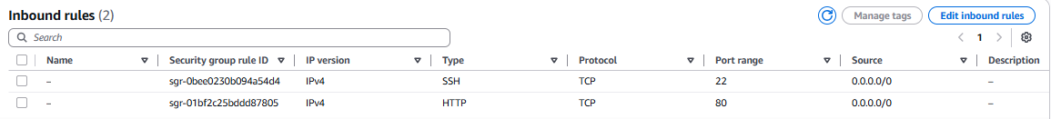
Then click:
Launch Instance

6. Connect to EC2
Once the instance is running, copy its public IP.
Example:
Public IPv4:
13.234.XX.XX
From your local machine:
ssh -i docker-key.pem ec2-user@13.234.XX.XX
For Amazon Linux, the default user is generally:
ec2-user
After successful login:
[ec2-user@ip-172-31-xx-xx ~]$

7. Verify Operating System
Run:
cat /etc/os-release
You should see something similar to:
NAME="Amazon Linux"
VERSION="2023"
Also check the kernel:
uname -r

8. Update Packages
Run:
sudo dnf update -y
This updates the installed packages and package metadata.

9. Install Docker
On Amazon Linux 2023, install Docker using:
sudo dnf install docker -y
Verify the installation:
docker --version

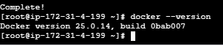

10. Start Docker Service
Installing Docker does not necessarily mean that the Docker daemon is currently running.
Start it:
sudo systemctl start docker
Check the status:
sudo systemctl status docker
You should see:
Active: active (running)

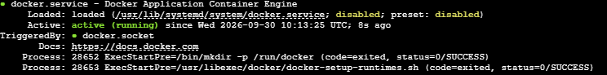

11. Enable Docker at Boot
We want Docker to automatically start whenever the EC2 server reboots.
Run:
sudo systemctl enable docker
Verify:
sudo systemctl is-enabled docker
Expected:
enabled

12. Test Docker
Run:
sudo docker run hello-world

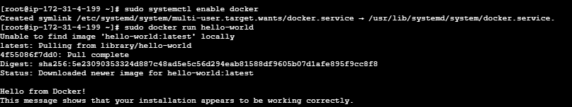
Docker will:
- Check whether the hello-world image exists locally.
- If it doesn't exist, contact Docker Hub.
- Download the image.
- Create a container.
- Start the container.
- Display the Docker welcome message.
- Container exits after completing the task.
You should see:
Hello from Docker!
This message shows that your installation appears to be working correctly.
This is our first successful Docker container.
- Pull 5 docker images. (nginx, Apache tomcat, ubuntu, Jenkins, SonarQube)

Pull 5 Docker Images

Images to Pull
We will pull these five images from Docker Hub:
- Nginx
- Apache Tomcat
- Ubuntu
- Jenkins
- SonarQube

1. Objective
The objective of this lab is to pull five commonly used Docker images from a container registry (Docker Hub) to an EC2 Docker host.
By completing this task, we will learn:
- What a Docker image is
- How to pull images from Docker Hub
- How to check downloaded images
- How to identify image tags and versions
- How Docker stores images locally
- The difference between an image and a container

Expected flow
Docker Host (EC2)
|
| docker pull
↓
Docker Hub
|
+------ nginx
+------ tomcat
+------ ubuntu
+------ jenkins
+------ sonarqube

2. Prerequisites
Before starting, make sure you have:

AWS
- AWS account
- EC2 instance
- Security Group
- EC2 key pair

EC2
Recommended:
OS : Amazon Linux 2023
CPU : 2 vCPU
RAM : 4 GB or more
Storage : 20 GB or more
Internet : Required
Note: Jenkins and especially SonarQube are much heavier than Nginx or Ubuntu. For simply pulling the images, the main requirement is sufficient disk space. Running all five simultaneously requires considerably more RAM/CPU.

Docker
Docker should already be installed and running.
Verify:
docker --version
Check Docker service:
sudo systemctl status docker

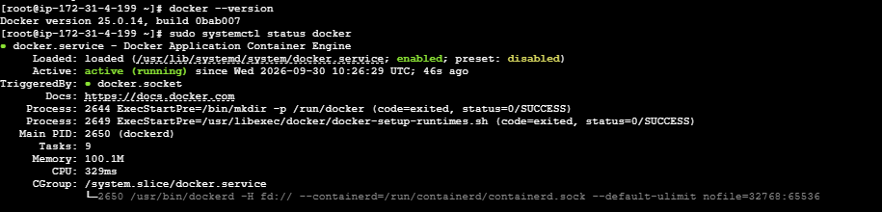

3. Connect to EC2
From your local machine:
ssh -i docker-key.pem ec2-user@<EC2-PUBLIC-IP>
Example:
ssh -i docker-key.pem ec2-user@13.234.xx.xx
Once connected:
[ec2-user@ip-172-31-xx-xx ~]$

4. Verify Docker
Run:
docker --version
Example:
Docker version 29.x.x
Then:
docker info
If Docker is working correctly, it will display information about the Docker daemon.

5. Check Existing Images
Before pulling anything, check whether the images already exist:
docker images
Initially you may see:
REPOSITORY TAG IMAGE ID CREATED SIZE
If these images are not present, we will pull them.
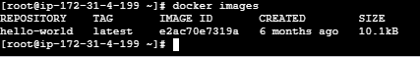

6. Pull Nginx Image
Run:
docker pull nginx
Docker will contact Docker Hub and download the Nginx image.
You may see output similar to:
Using default tag: latest
latest: Pulling from library/nginx
...
Status: Downloaded newer image for nginx:latest
Verify:
docker images nginx
Example:
REPOSITORY TAG IMAGE ID CREATED SIZE
nginx latest xxxxxxxx ... ...

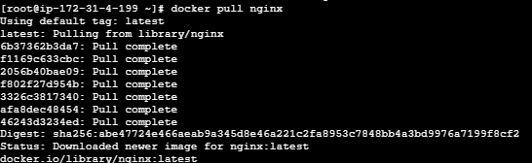

7. Pull Apache Tomcat Image
Run:
docker pull tomcat
Or, if you want a specific tag:
docker pull tomcat:10
For a learning lab, using an explicit supported version tag is generally preferable to relying on latest.
Verify:
docker images tomcat
Example:
REPOSITORY TAG IMAGE ID SIZE
tomcat 10 xxxxxxxx ...

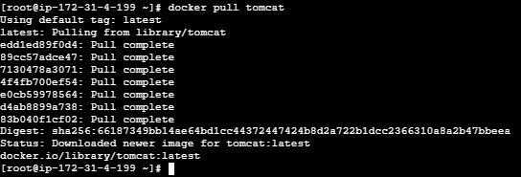

8. Pull Ubuntu Image
Run:
docker pull ubuntu
Docker will download the Ubuntu image.
Verify:
docker images ubuntu
Example:
REPOSITORY TAG IMAGE ID SIZE
ubuntu latest xxxxxxxx ...

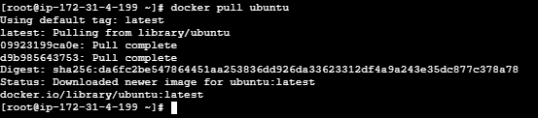

9. Pull Jenkins Image
The official Jenkins image is available from Docker Hub.
Pull it using:
docker pull jenkins/jenkins
By default this uses the latest tag.
For a more controlled lab, you can pull the LTS image:
docker pull jenkins/jenkins:lts
Verify:
docker images jenkins/jenkins
You should see something similar to:
REPOSITORY TAG IMAGE ID SIZE
jenkins/jenkins lts xxxxxxxx ...

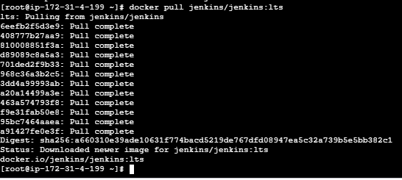

10. Pull SonarQube Image
Pull the official SonarQube image:
docker pull sonarqube
For a controlled lab, you can also use a specific supported tag rather than latest.
Verify:
docker images sonarqube

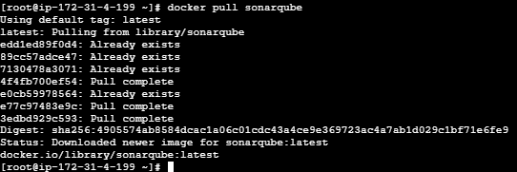

11. Verify All 5 Images
Run:
docker images

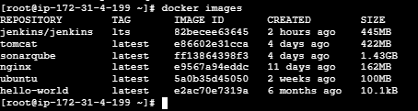
The exact image IDs, creation dates, tags, and sizes can vary because images are updated over time.

Real-Time DevOps Usage
These images represent different types of workloads:
Image | Typical usage
Nginx | Web server / reverse proxy
Tomcat | Java application server
Ubuntu | Linux base image / troubleshooting
Jenkins | CI/CD automation
SonarQube | Code quality and static analysis
A simplified DevOps environment could look like:
GitHub
|
↓
Jenkins
|
Build / Test
|
↓
SonarQube
|
Quality Check
|
↓
Docker Image
|
↓
Deployment
|
+---------+---------+
| |
Nginx Tomcat
| |
+--------+----------+
|
Application

- Run nginx container and expose on port 81.

1. Objective
To pull the Nginx Docker image, create and run an Nginx container, and expose the Nginx application on port 81 of the EC2 host.
The expected flow is:
Browser
|
| http://EC2-PUBLIC-IP:81
↓
EC2 Instance
Port 81
|
| Docker port mapping
↓
Nginx Container
Port 80
Here, 81 is the EC2 host port and 80 is the Nginx container port.

2. Prerequisites
Before starting, make sure you have:
- An AWS EC2 Linux instance.
- Docker installed and running.
- SSH access to the EC2 instance.
- EC2 Security Group access to TCP port 81.
- Internet connectivity to pull the Nginx image.
Check Docker:
docker --version
Check Docker service:
sudo systemctl status docker
If Docker is not running:
sudo systemctl start docker
Enable Docker at boot:
sudo systemctl enable docker

3. Step-by-Step Implementation

Step 1 — Connect to EC2
SSH into your EC2 instance.
For Amazon Linux:
ssh -i mykey.pem ec2-user@<PUBLIC-IP>
For Ubuntu:
ssh -i mykey.pem ubuntu@<PUBLIC-IP>

Step 2 — Verify Docker
Run:
docker --version
Example:
Docker version 29.x.x
Then:
docker ps
If it works, Docker is ready.

Step 3 — Pull Nginx Image
Pull the official Nginx image:
docker pull nginx
You can verify the image:
docker images
Expected:
REPOSITORY TAG IMAGE ID
nginx latest xxxxxxxxx

Step 4 — Run Nginx Container on Port 81
Run:
docker run -d --name nginx-container -p 81:80 nginx

Understand the command
docker run
Creates and starts a container.
-d
Runs the container in detached/background mode.
--name nginx-container
Assigns the container name.
-p 81:80
This is the most important part.
HOST PORT : CONTAINER PORT

81 : 80
So:
EC2 Port 81
↓
Docker
↓
Container Port 80
↓
Nginx

Step 5 — Check Running Container
Run:
docker ps
You should see something similar to:
CONTAINER ID IMAGE PORTS
xxxxxxxx nginx 0.0.0.0:81->80/tcp
This confirms:
EC2:81 → Container:80

Step 6 — Test from EC2
Run:
curl http://localhost:81
You should receive Nginx HTML output.
You can also use:
curl -I http://localhost:81
Expected:
HTTP/1.1 200 OK
Server: nginx

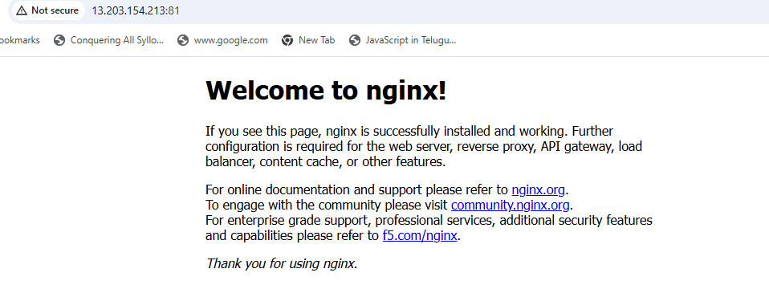

4. Configure AWS Security Group
This step is very important if you want to access Nginx from your browser.
Go to:
AWS Console → EC2 → Instances → Select your instance → Security → Security Groups
Go to:
Inbound rules → Edit inbound rules → Add rule
Configure:
Type: Custom TCP
Port: 81
Source: Your IP
For a temporary lab, you may use:
Source: 0.0.0.0/0
But for better security, restrict access to your own IP where possible.

5. Access Nginx from Browser
Open:
http://<EC2-PUBLIC-IP>:81
For example:
http://13.XXX.XXX.XXX:81
You should see:
Welcome to nginx!

8. Final Architecture
Internet
|
|
EC2 Public IP:81
|
AWS Security Group
|
↓
EC2 Host Port 81
|
Docker Port Mapping
|
↓
┌───────────────────────┐
│ Nginx Container │
│ │
│ Port 80 │
│ ↓ │
│ Nginx │
└───────────────────────┘
- Delete the Apache tomcat image from local.

Objective
The objective of this lab is to delete the Apache Tomcat Docker image from the local Docker host.
This helps us understand:
- How to identify Docker images
- How to check whether an image is being used
- How to remove a Docker image
- The difference between removing an image and removing a container
- How to verify successful image deletion

Expected flow
EC2 Instance
|
Docker
|
Tomcat Image
|
docker rmi
↓
Tomcat Image Deleted

2. Prerequisites
Before starting, make sure:
- EC2 instance is running.
- Docker is installed.
- Docker service is running.
- Apache Tomcat image exists locally.
- You have SSH access to the EC2 instance.
Verify Docker:
docker --version
Check Docker service:
sudo systemctl status docker
If Docker is not running:
sudo systemctl start docker

3. Connect to EC2
Connect to your EC2 instance:
ssh -i docker-key.pem ec2-user@<EC2-PUBLIC-IP>
Example:
ssh -i docker-key.pem ec2-user@13.234.xx.xx

4. Check Existing Docker Images
Before deleting Tomcat, list all local images:
docker images
Example:
REPOSITORY TAG IMAGE ID CREATED SIZE
nginx latest abc123 ... ...
tomcat 10 def456 ... ...
ubuntu latest ghi789 ... ...
jenkins/jenkins lts jkl012 ... ...
sonarqube latest mno345 ... ...
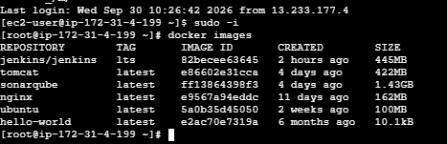

5. Identify the Tomcat Image
You can specifically check the Tomcat image:
docker images tomcat
Example:
REPOSITORY TAG IMAGE ID CREATED SIZE
tomcat latest def456789abc ... ...
Note the:
IMAGE ID
For example:
def456789abc

6. Check Whether Tomcat Containers Exist
Before deleting the image, check whether any containers were created from it.
Run:
docker ps -a
Look for containers using:
tomcat
You can also use:
docker ps -a --filter ancestor=tomcat
If there are no results, there are no containers based on that image.

7. Delete the Tomcat Image
If the image is not being used by any containers, run:
docker rmi tomcat:latest
The Tomcat image has now been removed from the local Docker host.
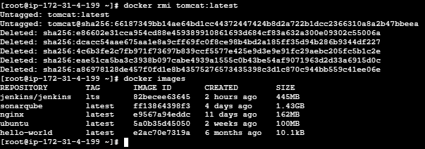

- Inspect the Jenkins image, SonarQube image.

Objective
The objective is to inspect the Jenkins and SonarQube Docker images available on the local Docker host and understand their configuration and metadata.
Using Docker inspection, we can examine:
- Image ID
- Tags
- Creation time
- Architecture and OS
- Image layers
- Environment variables
- Entrypoint
- Default command
- Exposed ports
- Working directory
- Volumes
- Labels
- Other image metadata

Expected flow
EC2 Instance
|
Docker
|
+-------------------+
| |
Jenkins Image SonarQube Image
| |
docker inspect docker inspect
| |
+---------+---------+
|
Image Metadata

2. Prerequisites
Before starting, make sure:

EC2
OS : Amazon Linux 2023
Docker : Installed
Internet : Available
Storage : Sufficient space

Docker service
Check:
sudo systemctl status docker
It should show:
Active: active (running)

Images
The images should already exist locally:
jenkins/jenkins
sonarqube
If they don't exist, pull them first:
docker pull jenkins/jenkins:lts
docker pull sonarqube

3. Connect to EC2
Connect using SSH:
ssh -i docker-key.pem ec2-user@<EC2-PUBLIC-IP>
Example:
ssh -i docker-key.pem ec2-user@13.234.xx.xx

4. Verify Docker
Run:
docker --version
Then:
docker info
If you receive a permission error, use:
sudo docker info

5. Check Available Images
First list all local images:
docker images
You should see something similar to:
REPOSITORY TAG IMAGE ID CREATED SIZE
nginx latest xxxxxxxx ... ...
tomcat 10 xxxxxxxx ... ...
ubuntu latest xxxxxxxx ... ...
jenkins/jenkins lts xxxxxxxx ... ...
sonarqube latest xxxxxxxx ... ...

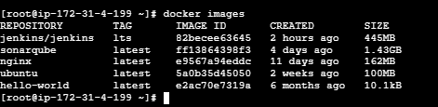
For this exercise, we are interested in:
jenkins/jenkins
sonarqube

PART A — Inspect Jenkins Image

6. Inspect Jenkins Image
Run:
docker inspect jenkins/jenkins:lts
This returns a large JSON document containing detailed metadata about the image.
You may see information such as:
[
{
"Id": "sha256:...",
"RepoTags": [
"jenkins/jenkins:lts"
],
"Architecture": "amd64",
"Os": "linux"
}
]

7. Check Jenkins Image ID
Instead of reading the complete output, use:
docker image inspect jenkins/jenkins:lts --format '{{.Id}}'
This is the unique identifier of the image.

8. Check Jenkins Repository and Tags
Run:
docker image inspect jenkins/jenkins:lts --format '{{json .RepoTags}}'

This tells us which repository and tag the image belongs to.

9. Check Jenkins Architecture
Run:
docker image inspect jenkins/jenkins:lts --format '{{.Architecture}}'
Example:
amd64

Check OS:
docker image inspect jenkins/jenkins:lts --format '{{.Os}}'
Expected:
Linux

10. Check Jenkins Entrypoint
Run:
docker image inspect jenkins/jenkins:lts --format '{{json .Config.Entrypoint}}'

The entrypoint tells Docker what executable should be started when a container is created from the image.

11. Check Jenkins Default Command
Run:
docker image inspect jenkins/jenkins:lts --format '{{json .Config.Cmd}}'
This displays the default command configured in the image.

Important concept
Docker images can define:
ENTRYPOINT
CMD
When a container is started, Docker uses these settings to determine what process should run.

12. Check Jenkins Environment Variables
Run:
docker image inspect jenkins/jenkins:lts --format '{{json .Config.Env}}'
You may see environment variables associated with the image.
To make the output easier to read:
docker image inspect jenkins/jenkins:lts \
--format '{{range .Config.Env}}{{println .}}{{end}}'
This displays each environment variable on a separate line.

13. Check Jenkins Exposed Ports
Run:
docker image inspect jenkins/jenkins:lts --format '{{json .Config.ExposedPorts}}'
You should see ports associated with Jenkins, commonly including:
8080/tcp
50000/tcp

Meaning
8080
is commonly used for the Jenkins web UI.
50000
has historically been used for Jenkins inbound agent communication.
Important: an image's EXPOSE metadata does not itself publish the port to the EC2 host. Publishing happens when you run the container with -p.
For example:
docker run -p 8080:8080 jenkins/jenkins:lts

14. Check Jenkins Volumes
Run:
docker image inspect jenkins/jenkins:lts --format '{{json .Config.Volumes}}'
This helps identify directories intended for persistent data.
For Jenkins, the important application data directory is:
/var/jenkins_home

This is important because Jenkins stores configuration, jobs, plugins, credentials-related configuration, and other Jenkins data there.

15. Check Jenkins Working Directory
Run:
docker image inspect jenkins/jenkins:lts --format '{{.Config.WorkingDir}}'
If the image defines a working directory, it will be displayed.

16. Check Jenkins Image Layers
Run:
docker history jenkins/jenkins:lts
You will see multiple layers:
IMAGE CREATED CREATED BY
xxxxxxxx ... ...
xxxxxxxx ... ...
xxxxxxxx ... ...

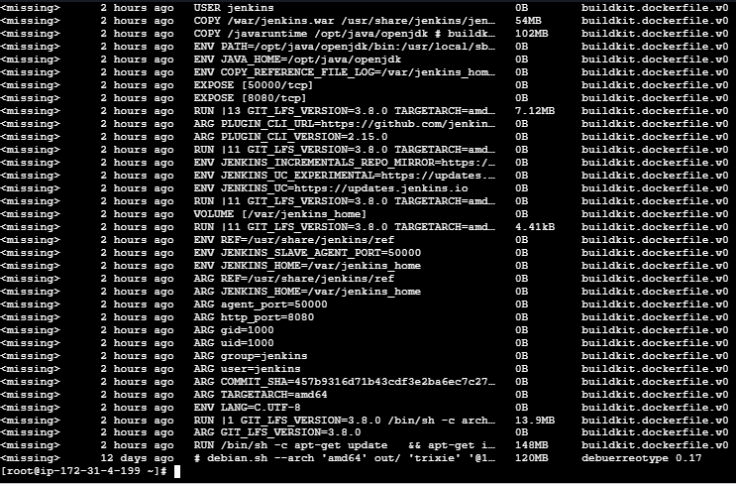

Why are layers important?
A Docker image is built from multiple layers.
Conceptually:
Jenkins Image
|
+--- Base Linux layer
|
+--- Java/runtime layer
|
+--- Jenkins dependencies
|
+--- Jenkins application
|
+--- Configuration
Docker can reuse unchanged layers between images, which helps reduce storage and transfer requirements.

PART B — Inspect SonarQube Image

17. Inspect SonarQube Image
Run:
docker inspect sonarqube
This provides detailed metadata for the SonarQube image.

18. Check SonarQube Image ID
Run:
docker image inspect sonarqube --format '{{.Id}}'
Example:
sha256:xxxxxxxxxxxxxxxx

19. Check SonarQube Repository and Tag
Run:
docker image inspect sonarqube --format '{{json .RepoTags}}'
Example:
["sonarqube:latest"]
If you pulled a specific version, the tag will be different.

20. Check SonarQube Architecture
Run:
docker image inspect sonarqube --format '{{.Architecture}}'

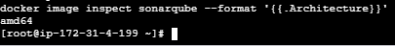
Check OS:
docker image inspect sonarqube --format '{{.Os}}'
Typically:
Linux

21. Check SonarQube Environment Variables
Run:
docker image inspect sonarqube \
--format '{{range .Config.Env}}{{println .}}{{end}}'
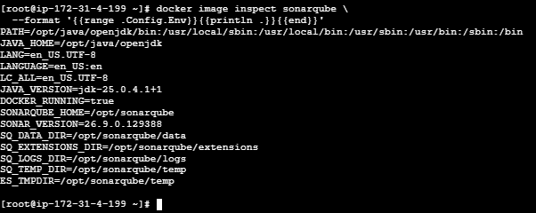
This displays environment variables configured in the image.
Environment variables are particularly important when running SonarQube because configuration such as database connectivity and application settings can be supplied through environment variables.

22. Check SonarQube Exposed Ports
Run:
docker image inspect sonarqube \
--format '{{json .Config.ExposedPorts}}'
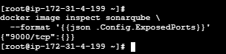
SonarQube commonly exposes:
9000/tcp
Port 9000 is commonly used for the SonarQube web interface.
Remember:
EXPOSE 9000
does not automatically make port 9000 accessible from the EC2 public IP.
You would need port publishing when creating the container:
docker run -p 9000:9000 sonarqube
and an appropriate EC2 Security Group rule if accessing it from outside the instance.

23. Check SonarQube Volumes
Run:
docker image inspect sonarqube \
--format '{{json .Config.Volumes}}'
This helps identify directories intended for persistent SonarQube data.

24. Check SonarQube Entrypoint
Run:
docker image inspect sonarqube \
--format '{{json .Config.Entrypoint}}'

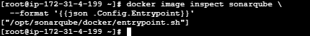
This tells us the entrypoint configured by the image.

25. Check SonarQube Default Command
Run:
docker image inspect sonarqube \
--format '{{json .Config.Cmd}}'
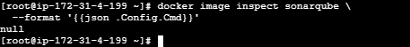
This displays the default command configured for the image.

26. Check SonarQube Image Layers
Run:
docker history sonarqube
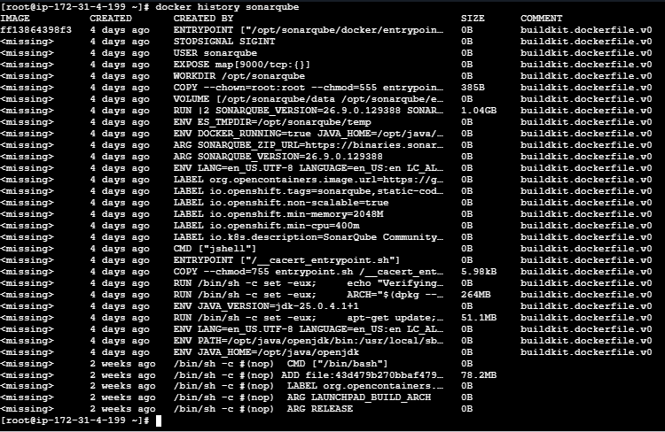
You will see the layers used to construct the SonarQube image.
Conceptually:
SonarQube Image
|
+--- Base OS
|
+--- Java/runtime
|
+--- SonarQube dependencies
|
+--- SonarQube application
|
+--- Configuration

27. Compare Jenkins and SonarQube
You can inspect both images together using:
docker images | grep -E 'jenkins|sonarqube'
Example:
jenkins/jenkins lts xxxxxxxx
sonarqube latest xxxxxxxx
Then inspect their histories:
docker history jenkins/jenkins:lts
docker history sonarqube

28. Useful Inspection Commands

Complete image inspection
docker inspect jenkins/jenkins:lts
docker inspect sonarqube

Image ID
docker image inspect jenkins/jenkins:lts --format '{{.Id}}'
docker image inspect sonarqube --format '{{.Id}}'

Architecture
docker image inspect jenkins/jenkins:lts --format '{{.Architecture}}'
docker image inspect sonarqube --format '{{.Architecture}}'

OS
docker image inspect jenkins/jenkins:lts --format '{{.Os}}'
docker image inspect sonarqube --format '{{.Os}}'

Environment
docker image inspect jenkins/jenkins:lts --format '{{range .Config.Env}}{{println .}}{{end}}'
docker image inspect sonarqube --format '{{range .Config.Env}}{{println .}}{{end}}'

Ports
docker image inspect jenkins/jenkins:lts --format '{{json .Config.ExposedPorts}}'
docker image inspect sonarqube --format '{{json .Config.ExposedPorts}}'

Layers
docker history jenkins/jenkins:lts
docker history sonarqube

29. Important Difference: docker inspect vs docker history

docker inspect
Shows metadata/configuration.
docker inspect jenkins/jenkins:lts
It can tell you:
Image ID
Tags
Architecture
OS
Environment variables
Entrypoint
CMD
Exposed ports
Volumes
Labels

docker history
Shows the image's layer history.
docker history jenkins/jenkins:lts
So remember:
docker inspect
↓
Image configuration / metadata

docker history
↓
Image layers / build history

30. Important Difference: Image Inspect vs Container Inspect
This is a common interview question.

Image
docker image inspect jenkins/jenkins:lts
Tells you about the image.

Container
After creating a Jenkins container:
docker inspect <container-name>
Tells you about the specific container, including its runtime configuration, networking, mounts, state, and other container-specific details.
Jenkins Image
|
docker run
↓
Jenkins Container
|
docker inspect container

31. Complete Lab Implementation
Execute these commands in order:

Step 1
docker images

Step 2
docker inspect jenkins/jenkins:lts

Step 3
docker image inspect jenkins/jenkins:lts --format '{{.Id}}'

Step 4
docker image inspect jenkins/jenkins:lts --format '{{json .Config.ExposedPorts}}'

Step 5
docker image inspect jenkins/jenkins:lts --format '{{range .Config.Env}}{{println .}}{{end}}'

Step 6
docker history jenkins/jenkins:lts

Step 7
docker inspect sonarqube

Step 8
docker image inspect sonarqube --format '{{.Id}}'

Step 9
docker image inspect sonarqube --format '{{json .Config.ExposedPorts}}'

Step 10
docker image inspect sonarqube --format '{{range .Config.Env}}{{println .}}{{end}}'

Step 11
docker history sonarqube

- Run Jenkins container and run one sample job.

Objective
The objective is to run Jenkins as a Docker container on an EC2 instance and execute a sample Jenkins job.
By completing this lab, you will learn:
- How to create a Jenkins container from a Docker image
- How to expose the Jenkins web UI
- How to persist Jenkins data using a Docker volume
- How to access Jenkins from a browser
- How to unlock and configure Jenkins
- How to create a sample job
- How to execute and verify a Jenkins build
- How Docker and Jenkins work together

Overall flow
AWS EC2
|
| Docker
|
Jenkins Container
|
+---- Port 8080
|
Jenkins Web UI
|
Sample Jenkins Job
|
Build
|
Console Output

2. Prerequisites

EC2 requirements
Use an EC2 instance with approximately:
OS : Amazon Linux 2023
CPU : 2 vCPU
RAM : 4 GB or more
Storage : 20 GB or more
Jenkins is relatively resource-intensive, so avoid trying to run Jenkins, SonarQube, Maven builds, etc. simultaneously on a very small instance.

Software requirements
Docker must already be installed.
Verify:
docker --version
Check Docker:
sudo systemctl status docker
It should show:
Active: active (running)

AWS Security Group
Add an inbound rule:
Type: Custom TCP
Port: 8080
Source: My IP
For temporary lab testing, you could use:
0.0.0.0/0
but restricting access to your IP is safer.

3. Connect to EC2
From your local machine:
ssh -i docker-key.pem ec2-user@<EC2-PUBLIC-IP>
Example:
ssh -i docker-key.pem ec2-user@13.234.xx.xx
Verify:
hostname

4. Verify Jenkins Image
First check whether the Jenkins image exists locally:
docker images
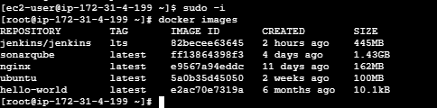

5. Create Jenkins Docker Volume
This is an important step.
Jenkins stores important information such as:
- Jobs
- Plugins
- Configuration
- Credentials configuration
- Build history
- User information
inside:
/var/jenkins_home
Create a Docker volume:
docker volume create jenkins_home
Verify:
docker volume ls
Expected:
DRIVER VOLUME NAME
local jenkins_home

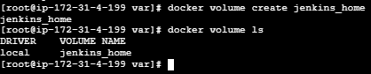

6. Run Jenkins Container
Run:
docker run -d \
--name jenkins \
-p 8080:8080 \
-p 50000:50000 \
-v jenkins_home:/var/jenkins_home \
jenkins/jenkins:lts

Explanation
docker run
Creates and starts a container.
-d
Runs the container in detached/background mode.
--name jenkins
Names the container:
jenkins
-p 8080:8080
Maps:
EC2 port 8080
↓
Container port 8080
This allows us to access the Jenkins web UI.
-p 50000:50000
Publishes the Jenkins inbound-agent port. It is not needed for this simple single-container job, but is commonly included when learning Jenkins controller/agent architecture.
-v jenkins_home:/var/jenkins_home
Mounts the Docker volume into Jenkins' data directory.
jenkins/jenkins:lts
is the image used to create the container.
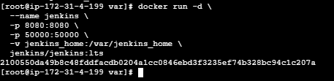

7. Verify Jenkins Container
Run:
docker ps
You should see something similar to:
CONTAINER ID IMAGE STATUS PORTS
xxxxxxx jenkins/jenkins:lts Up ... 0.0.0.0:8080->8080/tcp

This confirms that Jenkins is running.

8. Check Jenkins Container Logs
Run:
docker logs jenkins
Because Jenkins initialization can take some time, you may see startup messages.
To continuously monitor the logs:
docker logs -f jenkins
Press:
Ctrl + C
to stop following the logs.

9. Get Jenkins Initial Admin Password
Jenkins provides an initial administrator password during first-time setup.
Run:
docker exec jenkins cat /var/jenkins_home/secrets/initialAdminPassword

c5e42dcfca374f748116b63f9614895d
Copy this password.

Alternative
You can find it from the container logs:
docker logs jenkins
Look for the initial administrator password message.

10. Access Jenkins From Browser
Open your browser.
Use:
http://13.203.154.213:8080
You should see:
Unlock Jenkins
Enter the initial administrator password obtained from:
docker exec jenkins cat /var/jenkins_home/secrets/initialAdminPassword
Click:
Continue

11. Install Jenkins Plugins
Jenkins will provide two choices.
Select:
Install suggested plugins
Jenkins will install commonly used plugins.
Wait for the installation to finish.

12. Create Jenkins Administrator User
Create your Jenkins admin account.
Example:
Username:
admin

Password:
********

Full name:
Jenkins Administrator
Click:
Save and Continue

13. Jenkins URL
Jenkins may display:
Jenkins URL
For this lab, it can be:
http://<EC2-PUBLIC-IP>:8080/
Click:
Save and Finish
Then:
Start using Jenkins
You should now reach the Jenkins dashboard.
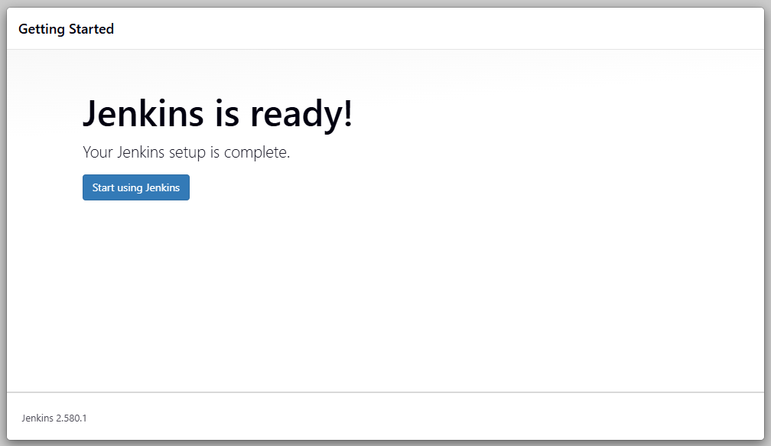

14. Create a Sample Jenkins Job
From the Jenkins dashboard:
Dashboard
↓
New Item
Enter:
Name:
Docker-Sample-Job
Select:
Freestyle project
Then click:
OK

15. Configure the Sample Job
You will see the job configuration page.
Scroll down to:
Build Steps
Click:
Add build step
Select:
Execute shell
Enter:
echo "================================"
echo "JENKINS DOCKER SAMPLE JOB"
echo "================================"

echo "Hostname:"
hostname

echo "Current User:"
whoami

echo "Current Date:"
date

echo "Docker Jenkins Container:"
echo "Jenkins job executed successfully!"

echo "================================"
echo "BUILD COMPLETED"
echo "================================"
Click:
Save

16. Run the Jenkins Job
Open:
Docker-Sample-Job
Click:
Build Now
Jenkins will create a build.
You should see:
Build History

#1
Click:
#1
Then:
Console Output

17. Verify Console Output
You should see output similar to:
Started by user admin

Building in workspace
...

JENKINS DOCKER SAMPLE JOB

Hostname:
xxxxxxxxxxxx

Current User:
jenkins

Current Date:
Wed Sep 30 ...

Docker Jenkins Container:
Jenkins job executed successfully!

BUILD COMPLETED

Finished: SUCCESS
The important result is:
Finished: SUCCESS

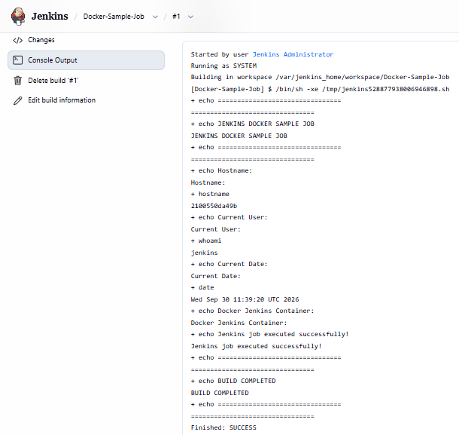
🎉 Your first Jenkins job has successfully executed inside a Jenkins Docker environment.

18. Verify the Job From Docker
Go back to your EC2 terminal.
Run:
docker ps
You should see:
jenkins/jenkins:lts
Check Jenkins container logs:
docker logs --tail 50 jenkins
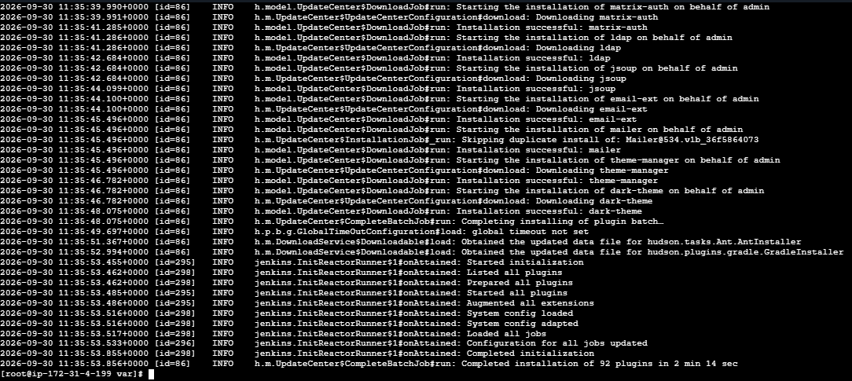

19. Verify Jenkins Data Persistence
This is an important practical concept.
Check the volume:
docker volume inspect jenkins_home
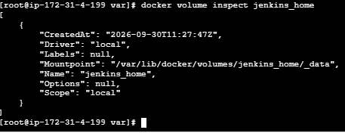
You will see information about the Docker volume.
Your Jenkins data is stored in:
jenkins_home
|
↓
/var/jenkins_home
inside the container.

20. Test Persistence
Now stop the Jenkins container:
docker stop jenkins
Check:
docker ps
Jenkins should no longer be running.
Start it again:
docker start jenkins
Check:
docker ps

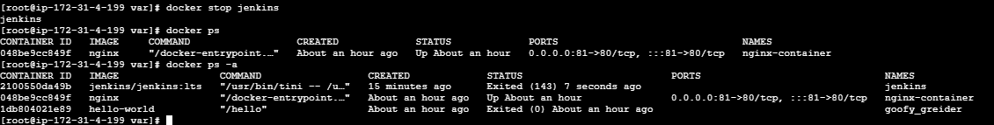
You should see Jenkins running again.
Open:
http://13.203.154.213:8080/job/Docker-Sample-Job/1/console
Your previously created:
Docker-Sample-Job
should still exist.
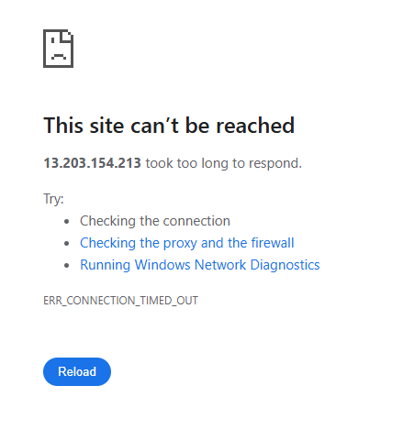

Why?
Because we used:
-v jenkins_home:/var/jenkins_home
The Jenkins data is stored in the Docker volume rather than being lost when the container is recreated.

21. Understand the Architecture
The final setup looks like:
AWS
|
VPC
|
EC2
|
Docker
|
+------------------+
| Jenkins Container|
| |
| Jenkins |
| /var/jenkins_home|
+--------+---------+
|
Docker Volume
jenkins_home
|
Jenkins Data
|
+------+------+
| |
Jobs Plugins
|
Builds
Browser:
Your PC
|
| HTTP :8080
↓
EC2 Public IP
|
↓
Docker Port 8080
|
↓
Jenkins Container :8080

22. Useful Commands

List containers
docker ps

List all containers
docker ps -a

Start Jenkins
docker start jenkins

Stop Jenkins
docker stop jenkins

Restart Jenkins
docker restart jenkins

View logs
docker logs jenkins

Follow logs
docker logs -f jenkins

Get Jenkins password
docker exec jenkins cat /var/jenkins_home/secrets/initialAdminPassword

Open shell inside Jenkins container
docker exec -it jenkins bash

Inspect container
docker inspect jenkins

Check volume
docker volume inspect jenkins_home

23. Important Difference — Docker Host vs Jenkins Container
This is especially important for your DevOps practice.
EC2 HOST
|
+--- Docker
|
+--- Jenkins Container
|
+--- Jenkins
|
+--- /var/jenkins_home
When you run:
docker ps
on the EC2 host, you are looking at Docker containers.
When you run:
docker exec -it jenkins bash
you enter the Jenkins container.
For example, inside the container:
whoami
may return:
jenkins

24. One Important Point About the Sample Job
Our sample job only executes commands available inside the Jenkins container.
For example:
echo
hostname
whoami
date
will work because they are available in the Jenkins container.
If later you want Jenkins to perform:
Git clone
Maven build
Docker build
Docker push
SonarQube analysis
AWS deployment
Tomcat deployment
then the Jenkins container needs the required tools and/or access to external build agents.
A common real-world architecture is:
Jenkins Controller
Docker Container
|
Pipeline / Jobs
|
Jenkins Agent
|
+--------------+--------------+
| | |
Git Maven Docker
| | |
GitHub Build Image Build
This is the next level after this basic Jenkins-container exercise.

25. Cleanup
If you want to stop Jenkins:
docker stop jenkins
If you want to remove the container:
docker rm jenkins
Because the data is stored in:
jenkins_home
the volume remains unless you explicitly delete it.
Check:
docker volume ls
If you intentionally want to delete all Jenkins data:
docker volume rm jenkins_home
⚠️ This removes the persistent Jenkins data, including your jobs and configuration. Don't run it if you want to keep your Jenkins setup.

Commands to remember
docker pull jenkins/jenkins:lts

docker volume create jenkins_home

docker run -d \
--name jenkins \
-p 8080:8080 \
-p 50000:50000 \
-v jenkins_home:/var/jenkins_home \
jenkins/jenkins:lts

docker ps

docker logs jenkins

docker exec jenkins cat /var/jenkins_home/secrets/initialAdminPassword
Then access:
http://<EC2-PUBLIC-IP>:8080
and create:
Docker-Sample-Job
↓
Freestyle Project
↓
Build Steps
↓
Execute shell
↓
Build Now
↓
Console Output
↓
Finished: SUCCESS

